Type Paper Title Here
Insert First Author¹, Second Author², and Third Author Here¹

¹First Company Name
First Address
More Address
(123) 456-7890; fax (123) 789-3456; email me@efghij.com

²Different Company Name
Different Company Address
More Address
(123) 456-7890; fax (123) 789-3456; email me@efghij.com

ABSTRACT
The body text of the paper is 10 pt Times New Roman with 1.15 line spacing. The margins are 1 in. on each side. Copy and paste your body text here. Choose the style called BODY TEXT PAPER SUMMARY. There is one space between this paragraph and the Keywords.

Keywords: insert keywords here, samples include vibration analysis, ultrasonic testing, steel enhancement

SUBHEAD 1 PAPER SUMMARY
Subhead 1 is 12 pt Times New Roman bold with 1.15 line spacing. This subhead is in all caps. The body text of the paper is 10 pt Times New Roman with 1.15 line spacing. Copy and paste your body text here. Choose the style called BODY TEXT PAPER SUMMARY. There is one space between paragraphs.

Subhead 2 Paper Summary
Subhead 2 is called SUBHEAD 2 PAPER SUMMARY. It is 12 pt Times New Roman bold with 1.15 line spacing. The wording is in both upper and lower case letters. Copy and paste your body text here. Choose the style called BODY TEXT PAPER SUMMARY. There is one space between paragraphs.

Refer to Table 1 in the text. The title of a table uses the style CAPTIONS PAPER SUMMARY. There is one space between a paragraph of text and a table.

Table 1: This is the description of this sample table. The style is called CAPTIONS PAPER SUMMARY. Create a table from the New Tables menu in Word. Use 10 pt Times New Roman in tables.
Cell Title | Second Cell Title | Third Cell Title | Another Cell Title | Final Cell Title
Table text | 123456 | Sample text | 123.456 | Sample text
More text | 87654 | More text | 798.222 | More text
More text | 87654 | More text | 798.222 | More text

Subhead 3 Paper Summary
Subhead 3 is 10 pt Times New Roman bold and italic, with 1.15 line spacing. Use the style called SUBHEAD 3 PAPER SUMMARY.

This is a bullet list:
- For a bullet list, use the style BODY TEXT PAPER SUMMARY.
- 10 pt Times New Roman with 1.15 line spacing.
- Select the round bullet from the bullet menu.
- Refer to Figure 1 in the text.

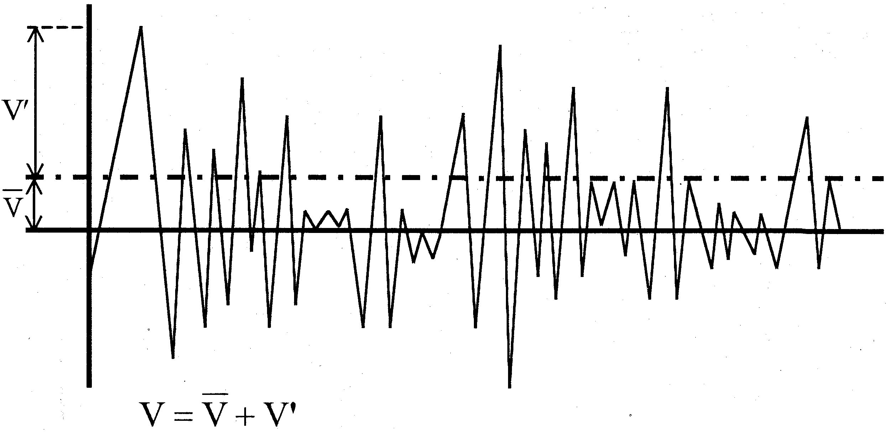  (a) | 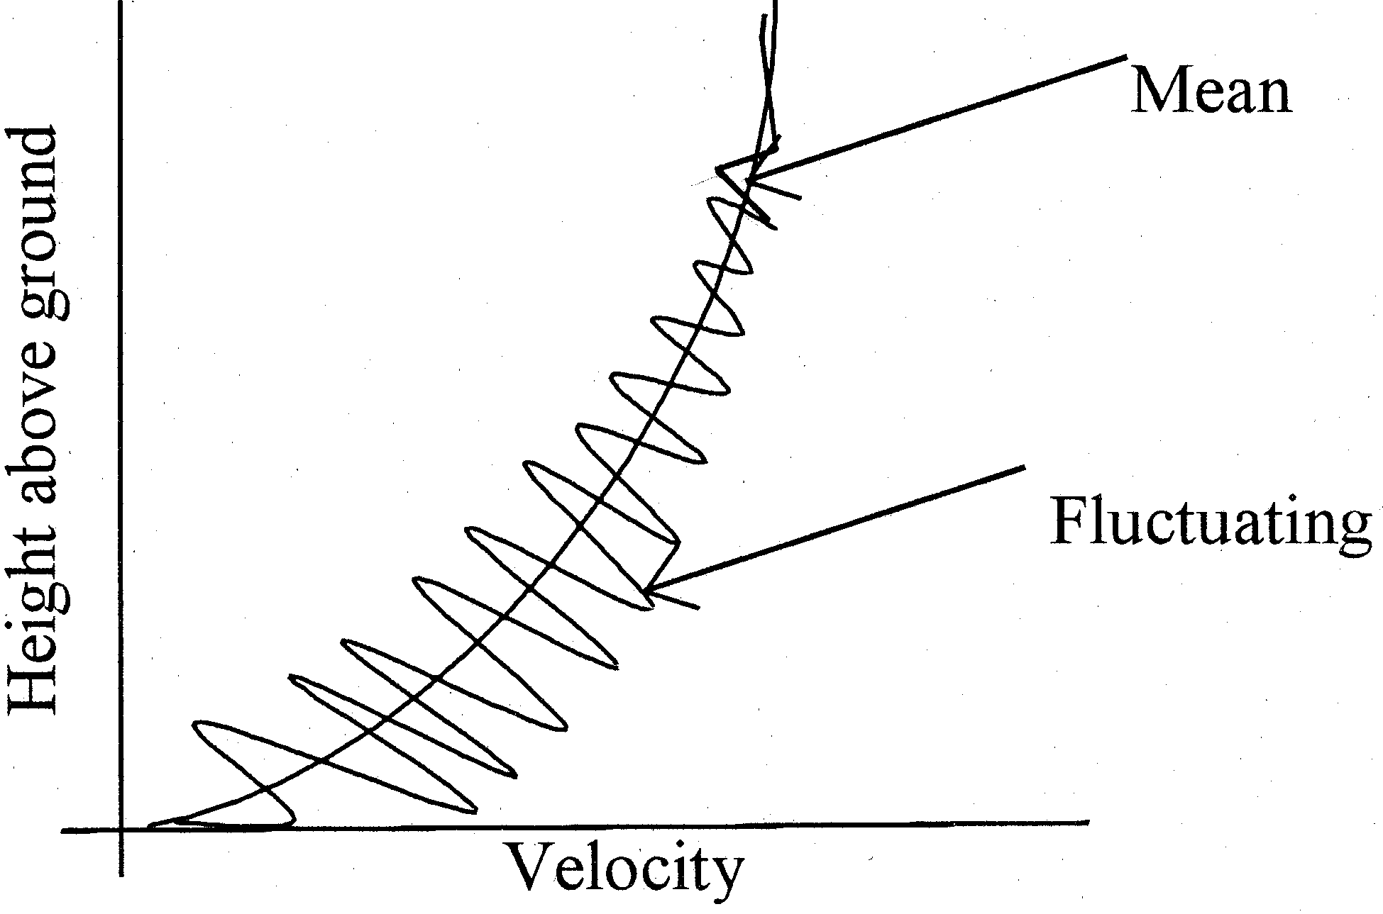  (b)
Figure 1: Number figures consecutively. (a) Use the style called CAPTIONS PAPER SUMMARY.(b) Refer to Figure 1 in the text.

(Eq. 1)

where
I = explain what I is here,
D = explain what D is here.

Set equations in MathType if possible. Number equations sequentially. Refer to Equation 1 in the text.

References should follow the ASME guidelines. Citations should appear in the text in numerical order, in the order used. Enclose each numbered citation in brackets [1] within the text. At the end of the paper, the list of references will appear in the order in which they were cited. Use a 1/4 in. [2] hanging indent. The following website may be of help: libraryguides.missouri.edu/mae/asmecitation.

REFERENCES
(1) Moore, D.G. and P.O. Moore,2008,Nondestructive Testing Handbook, third edition: Vol. 3: Magnetic Particle Testing,ASNT, Columbus, OH.
(2) Golosinski, T.S., 1998, “Magnetic Examinations of Wire Ropes,” OIPEEC Bulletin, 75(3), pp 27-36.

